**Assignment -3**

Cloud object storage and Watson assistant

|  |  |
| --- | --- |
| Assignment Date | 30 September 2022 |
| Student Name | Priya Dharshini |
| Student Roll Number | 922119104032 |
| Maximum Marks | 2 Marks |

**Question-1:**

Create a Bucket in IBM object storage

|  |
| --- |
| **Solution:** |
|  |  |

**Question-2:**

**Upload an 5 images to ibm object storage and make it public. Write html code to displaying all the 5 images.**

**Solution:**

**Html code:**

**<!DOCTYPE html>**

**<html>**

**<head>**

**<link rel="stylesheet" href="https://** **s3.jp-tok.cloud-object-storage.appdomain.cloud/inventorymanagmentsystemforretailersassignment3 /new.css">**

**</head>**

**<body>**

**<h1>This images are from the cloud object storage</h1>**

**<div class="grid-container">**

**<div class="item1"><img src="https://** **s3.jp-tok.cloud-object-storage.appdomain.cloud/inventorymanagmentsystemforretailersassignment3/1.jpg " alt="Girl in a jacket"></div>**

**<div class="item2"><img src="https://** **s3.jp-tok.cloud-object-storage.appdomain.cloud/** **inventorymanagmentsystemforretailersassignment3 /2.jpg" alt="dog"></div>**

**<div class="item3"><img src="https://** **s3.jp-tok.cloud-object-storage.appdomain.cloud/** **inventorymanagmentsystemforretailersassignment3 /33.jpg" alt="** **dog "></div>**

**<div class="item4"><img src="https://** **s3.jp-tok.cloud-object-storage.appdomain.cloud/** **inventorymanagmentsystemforretailersassignment3 /4.jpg" alt="** **dog "></div>**

**<div class="item5"><img src="https://** **s3.jp-tok.cloud-object-storage.appdomain.cloud /** **inventorymanagmentsystemforretailersassignment3/5.jpg" alt="** **dog "></div>**

**</div>**

**</body>**

**</html>**

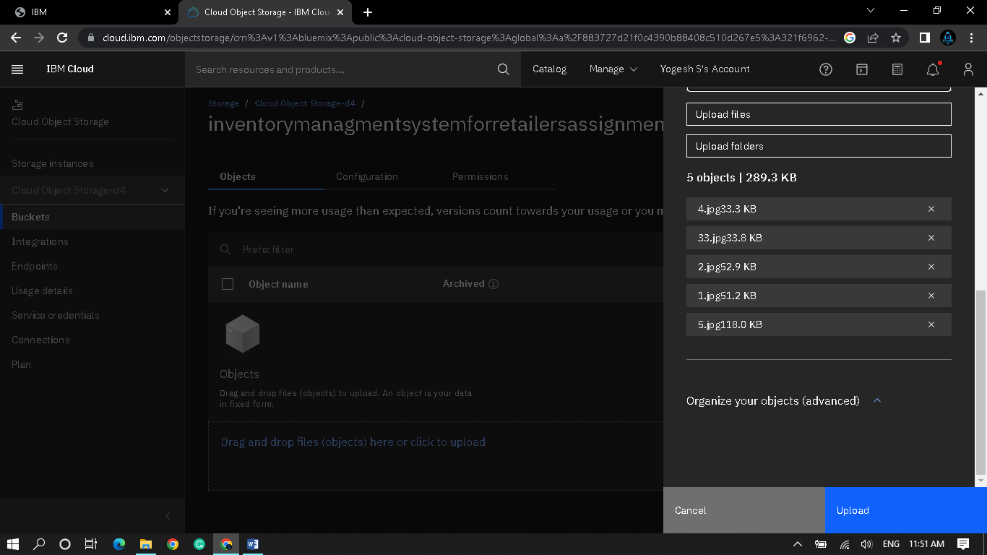

**Question-3:**

Upload a css page to the object storage and use the same page in your html code.

Solution:

New.css uploaded to the object storage and used the same page in html code

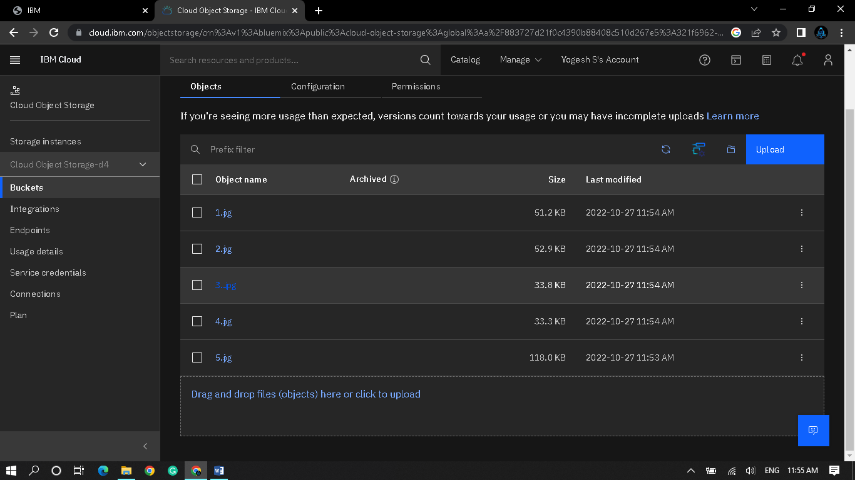

Css page used in html page

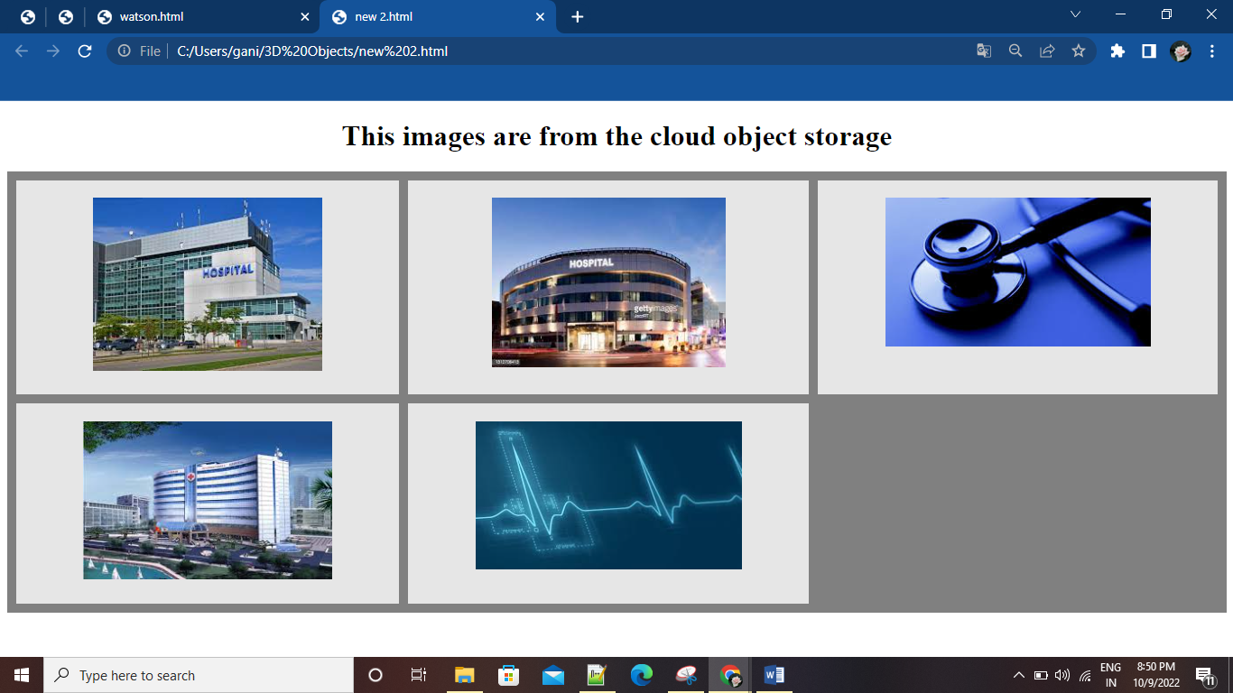

**Question-4:**

Design a Chabot using IBM Watson assistant for hospital. Ex: User come the query to know the braches for that hospital in your city.

Solution:

URL for: https://web-chat.global.assistant.watson.appdomain.cloud/preview.html?backgroundImageURL=https%3A%2F%2Fau-syd.assistant.watson.cloud.ibm.com%2Fpublic%2Fimages%2Fupx-0516420a-a54c-4626-b459-481c71f5ac41%3A%3A512d2748-7659-4d70-ba79-81fcedac9d3b&integrationID=0b305951-d464-4f72-9cc7-938932287427&region=au-syd&serviceInstanceID=0516420a-a54c-4626-b459-481c71f5ac41

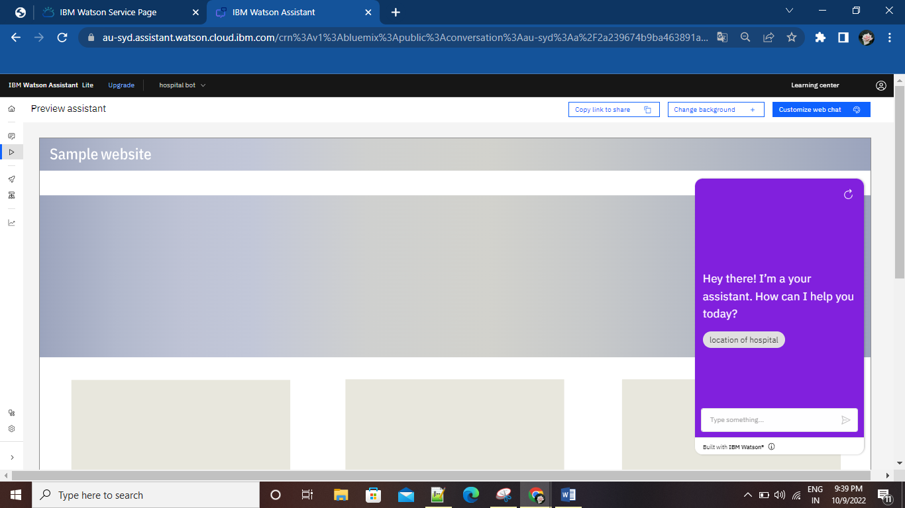

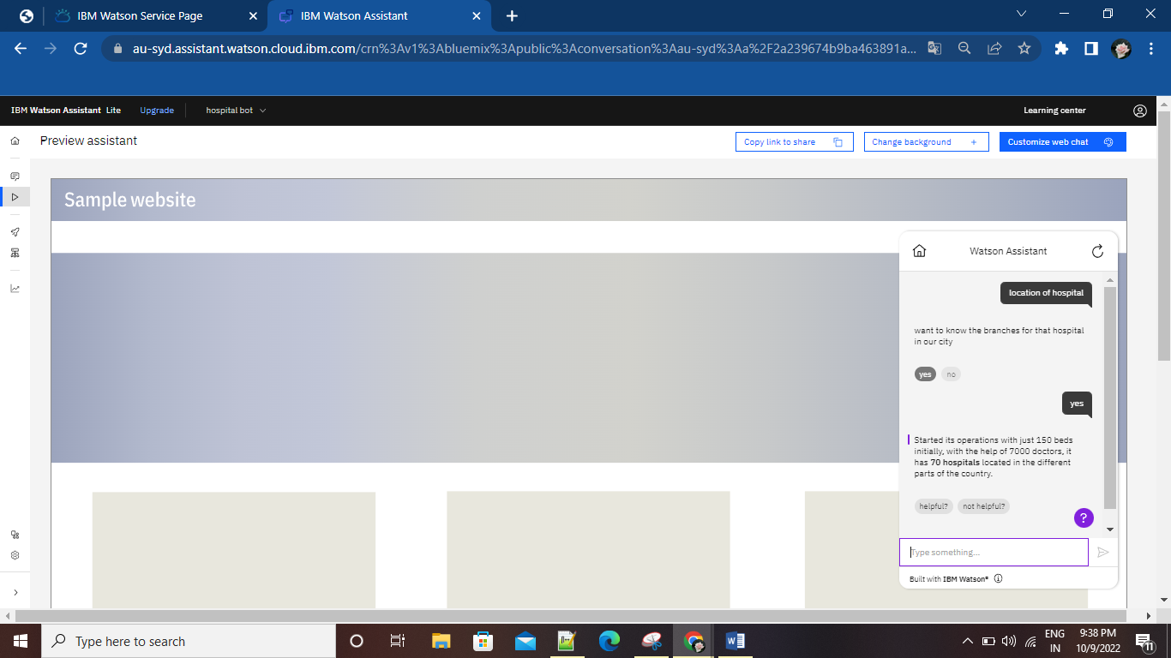

**Question-5:**

Create Watson assistant service with 10 steps and use 3 conditions in it. Load that script in html page

Solution:

<!DOCTYPE html>

<html>

<head>

<link rel="stylesheet" href="https://cloud-object-storage-er-cos-standard-1xw.s3.jp-tok.cloud-object-storage.appdomain.cloud/new.css">

</head>

<script>

window.watsonAssistantChatOptions = {

integrationID: "0b305951-d464-4f72-9cc7-938932287427", // The ID of this integration.

region: "au-syd", // The region your integration is hosted in.

serviceInstanceID: "0516420a-a54c-4626-b459-481c71f5ac41", // The ID of your service instance.

onLoad: function(instance) { instance.render(); }

};

setTimeout(function(){

const t=document.createElement('script');

t.src="https://web-chat.global.assistant.watson.appdomain.cloud/versions/" + (window.watsonAssistantChatOptions.clientVersion || 'latest') + "/WatsonAssistantChatEntry.js";

document.head.appendChild(t);

});

</script>

<body>

<h1>This images are from the cloud object storage</h1>

<div class="grid-container">

<div class="item1"><img src="https://cloud-object-storage-er-cos-standard-1xw.s3.jp-tok.cloud-object-storage.appdomain.cloud/1.jpg" alt="Girl in a jacket"></div>

<div class="item2"><img src="https://cloud-object-storage-er-cos-standard-1xw.s3.jp-tok.cloud-object-storage.appdomain.cloud/2.jpg" alt="Girl in a jacket"></div>

<div class="item3"><img src="https://cloud-object-storage-er-cos-standard-1xw.s3.jp-tok.cloud-object-storage.appdomain.cloud/3.jpg" alt="Girl in a jacket"></div>

<div class="item4"><img src="https://cloud-object-storage-er-cos-standard-1xw.s3.jp-tok.cloud-object-storage.appdomain.cloud/4.jpg" alt="Girl in a jacket"></div>

<div class="item5"><img src="https://cloud-object-storage-er-cos-standard-1xw.s3.jp-tok.cloud-object-storage.appdomain.cloud/5.jpg" alt="Girl in a jacket"></div>

</div>

</body>

</html>

Output:

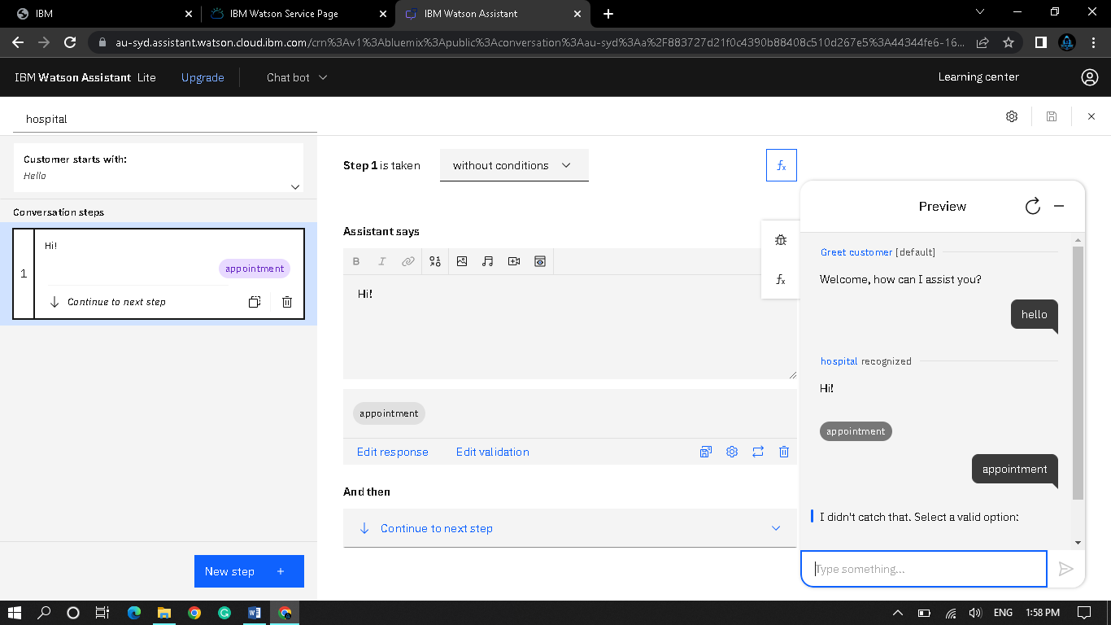

URL for chatbot: <https://web-chat.global.assistant.watson.appdomain.cloud/preview.html?backgroundImageURL=https%3A%2F%2Fau-syd.assistant.watson.cloud.ibm.com%2Fpublic%2Fimages%2Fupx-0516420a-a54c-4626-b459-481c71f5ac41%3A%3A512d2748-7659-4d70-ba79-81fcedac9d3b&integrationID=0b305951-d464-4f72-9cc7-938932287427&region=au-syd&serviceInstanceID=0516420a-a54c-4626-b459-481c71f5ac41>

URL for webpage: https://cloud-object-storage-er-cos-standard-1xw.s3.jp-tok.cloud-object-storage.appdomain.cloud/new%202.html